Mary Kuster
Amanda Gordon Miller
Larry Phelps
Claudia Coonen
Renee A. Ugrin
Mellissa Read-Devine
Jill Saxton Smith
Julio Rodriguez
Karma Grotelueschen
Jean Womack
Joseph Taylor
Robert Arnold
Eileen Corder
Constance Brewer
Diane Cutter
George Jarvis
Andrea Starkey
Tina Browder
Ellen Shipley
Mary Grassell
Tiberiu Chelcea
Daryl DePry
Juergen Stieler
Ittai Altshuler

[Baren Exchange #44]
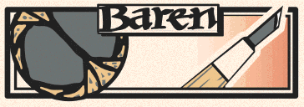
- Introduction: [Baren] runs an active program of print exchanges, in which the members (in groups of up to thirty) make editions of thirty prints each and exchange them with each other. The Exchange program was initiated in late 1998, and has continued at the rate of a new folio being produced about every three months.
- Participation: You must be an active member of [Baren] in order to participate in this exchange. The mailing list that makes up [Baren] is open to everyone to join, and the membership is thus made up of a mix of 'lurkers' and active participants in the forum.
- Medium: Woodblock print (hand rubbed or pulled on a press, B&W or colour, any pigments, any paper). Note: The Baren Exchange is a program for forum members to create, exchange and display editions of woodblock prints. Relief prints pulled from wood substitutes and wood-like materials, including linoleum, corian, MDF, resingrave, and similar are acceptable as are collagraphs. Coordinators are obligated to reject prints whose primary method of production is by other means. For example: monotype, intaglio, stencil, lithography, ink jet, laser, photocopy, etc are to be rejected by the coordinator.
- Technique: 3 Color Reduction Block
- Theme: Open
- Paper size: chu-ban -- about 10 x 7.5 inches
- Image size: Any size and orientation
- Paper type: No restriction
- Registration period: January 1, 2010
- Drop-out deadline: April 1, 2010
- Delivery deadline: May 1, 2010
- Archives: Prints from [Baren] exchanges 1-30 are archived at The Spencer Museum of Art at the University of Kansas in Lawrence, Kansas. Prints from exchanges 31 forward are archived at The University of Kentucky Museum of Art in Lexington, Kentucky.

soccer games and can't help but stare past the fields and activity to the tree line that lies beyond and the leaves just beginning to come on, with shades of chartreuse mixed with the reds of the leafless branches. The print was made with four reductions and about six impressions to achieve some gradient in the foreground and sky.

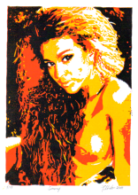
Juergen Stieler - Flensburg, Germany
Print Title: “Sunny”
Paper Dimension: 19 x 25 cm
Image Dimension: 15.5 x 22 cm
Block: Linoleum
Ink: Gerstaecker relief printing inks
Paper: Masa
Edition: 49

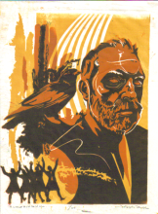
Joseph Taylor - Evanston, Illinois
Print Title: “A Little Bird Told Me”
Paper Dimension: 7.5 x 10 inches
Image Dimension: 7 x 9.5 inches
Block: Shina
Ink: Graphic Chemical
Paper: Sekishu
Edition: 60

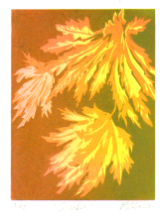Renee Ugrin - Damascus, Oregon
Print Title: “October”

Paper Dimension: 7.5 X 10 inches
Image Dimension: 6 X 8 inches
Block:
Ink: Dan Smith oil base inks.
Paper:
Edition:
Comments: Three stage reductive woodblock print, a light pink/yellow, an orange/red and a transparent brown/green. I am very fond of Autumn’s palette.

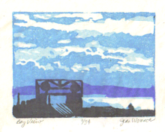
Jean Womack - Richmond, California
Print Title: “Bay View”
Paper Dimension: 7.5 x 10 inches
Image Dimension: 5 X 6.5 inches
Block: Blick Balsa Foam
Ink: Createx pure pigment and Monoprint Extender
Paper: Mulberry
Edition: 34
Comments: This was the first time I tried the new Balsa Foam. It's very
easy to cut, but it dents easily and did not hold a sharp corner. It held up well to printing and accepts water based ink very nicely. It does give print
a weird gritty feel, as it leaves a deposit of the new plastic or whatever it
is they make that stuff from. I will probably use this material for printmaking at least one more time. Thanks for giving me the nudge I needed to make another reduction print.

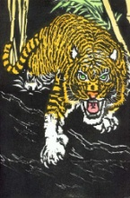
Bonus Print

Julio Rodriguez – Skokie, Illinois
Print Title: “In Danger”

Block: Birch plywood
Ink: Water-based pigments
Paper: Rives White (heavy)
Edition:40

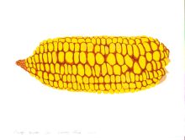Larry Phelps - Rock Springs, Wisconsin
Print Title: “Judy’s corn”
Paper Dimension: 10 inches x 7.5 inches
Image Dimension: 8 inches by 3 inches
Block: Sintra, four printings
Ink: Daniel Smith water soluble
Paper: Rives BFK
Edition: 46
Comments: Growing up in Iowa I saw lots of ears of corn, which have a beauty their own, a sort of mix of industrial precision with scattered "mistakes". The title came from a farmer neighbor’s wife having brought
this particular ear over to feed our chickens after it fell aside from the combine. I mistakenly printed on 7.5 x 11 paper so had to cut it down later to fit the rules, making the image sit a little close to the sides of the paper.

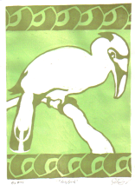
Julio Rodriguez – Skokie, Illinois
Print Title: “Big Bird”
Paper Dimension: 10 inches x 7.5 inches
Image Dimension: 9 inches by 7 inches
Block: Linoleum, three impressions
Ink: Dick Blick water soluble
Paper: Arches white
Edition: 30
Comments: Take back to wallpaper designs from long ago.

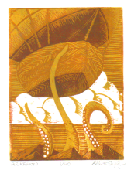Ellen Shipley - Santa Clarita, California
Print Title: “Air Kraken”
Paper Dimension: chu-ban
Image Dimension: 8" x 6 "
Block: shina
Ink: Daniel Smith water soluble ink
Paper: Rives BFK
Edition: 40
Comments: This is my second reduction block and I found it both exhilarating and frightening. I’m not used to doing a total edition at one
time. There is always the danger of damaging the block and thus the
whole run at any stage.
Overall I’m pleased with the result. I would have gone back and changed
a couple things, but of course there is no going back with a reduction
block. There are two basic color effects, stemming from experiments with the lightest color. I like them both. It changes the mood of the print slightly.
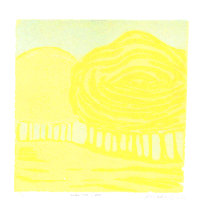
Jill Saxton Smith - Cairo, Egypt Print Title: “Morning Glow”
Paper Dimension: chu-ban
Image Dimension: 5" x 5"
Block: Birch plywood
Ink: Caligo oil
Paper: American Masters Printmaking Paper
Edition: 31

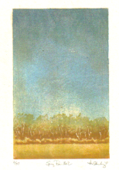Andrea Starkey - Bellbrook, Ohio
Print Title: “Spring Rain No.2”
Paper Dimension: 7.5" x 10"
Image Dimension: 4.5" x 7"
Block: birch plywood
Ink: Akua Kolor Monotype Ink
Paper: Sekishu, Kitakata & Mulberry
Edition: 37
Comments: This print is based on a view with which I am very familiar.
I have spent countless rainy spring Saturday mornings at my children's

Colophon
Baren Exchange # 44 - January to May 2010

Exchange Coordinator – Julio Rodriguez
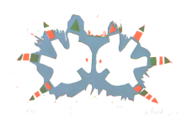

Ittai Altshuler - Abbirim, Israel
Print Title: “Amusing Myself”
Paper Dimension: 25.5cm / 19cm
Image Dimension: about 20cm / 13cm
Block: foam pvc
Ink: oil based
Paper: arches
Edition: 31
Comments: In front signed in Hebrew in the back signed in English

Robert Arnold - Las Vegas, Nevada
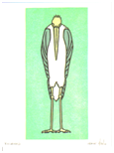Print Title: “Crane”
Paper Dimension: 10" x 7.5"
Image Dimension: 9" x 4.25"
Block: Linoleum
Ink: Van Son Oil Based
Paper: Graphic Heavyweight
Edition:
Comments: Image was a 4 color reduction print. It was printed on a 1927 Chandler & Price hand fed platen press. The linoleum sheet was mounted on a base that made it type high. This was mounted in a chase and remained locked up until the print was completed. The chase was removed from the press after each color and was carved in preparation for the new color. It was then re-inserted into the press for each color.

Constance Brewer - Gillette, Wyoming
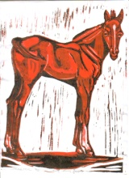Print Title: “Spring Foal”
Paper Dimension: chu-ban
Image Dimension: 10 x 7.5 inches
Block: Lino
Ink: Graphic Chemical Water Soluble
Paper: Masa
Edition: 45
Comments: My first reduction in many, many years. I wanted it to look like
a print from the horse books I read as a child. After battling the ink layers, I have a better understanding of the process!

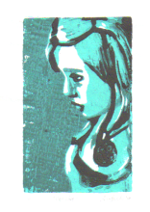
Tina Browder - Chicago, Illinois
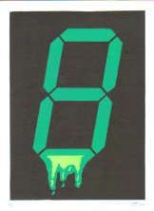Print Title: “Pensive”
Paper Dimension: 7.5” x 10"
Image Dimension: 3.5” x 5”
Block: Bass
Ink: Blick Water soluble Ink
Paper: Hosho
Edition: 30
Comments: My muse; Charolette.

Tiberiu Chelcea - Pittsburgh, Pennsylvania
Print Title:
Paper Dimension: 10 x 7.5"
Image Dimension: 9” x 6.5"
Block: Wood (birch plywood)
Ink: Caligo; Gouache mixed with Transparent base, Daniel Smith
Paper: Masa
Edition: 35
Comments: Colors (in order): light green, dark green, black (printed twice, once with the press and once with a baren for uniform coverage). Printed dry. Registration: kento.

Claudia Coonen – Haiku, Hawaii
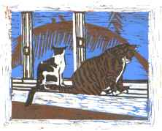Print Title: “Wishfull Thinking”
Paper Dimension: 10.5 x 7 inches
Image Dimension: 7 x 5.5 inches
Block: shina
Ink: DS water soluble
Paper: western
Edition: 36
Comments: The Kitties are my friend's sisters, and she wanted a print
using some of her sisters photo., The palm frond w/ birds is from a trip I
did to Kauai.

Eileen Corder - Hayfork, California
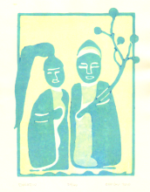Print Title: “Dosojin”
Paper Dimension: 7.5 x 10 inches
Image Dimension: 6 x 8 inches
Block: shina plywood
Ink: akua kolor, moku hanga
Paper: shin torinoko
Edition: 40
Comments: Dosojin are Japanese stone deities set along roads for protection against evil forces. They often depict a man and a woman standing side by side. There’s something very balanced and easy about this image which to me symbolizes unity. May you and all beings experience the joy of a precious other.

Diane Cutter - Ceiba, Puerto Rico
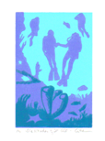Print Title: "The Wonder of it All"
Paper Dimension: 10" x 7.5"
Image Dimension: 6" x 4"
Block: Shina
Ink: Daniel Smith Relief (Titanium White);
Handschy Litho Inks (Reddish Purple P868 & Cerulean Blue B7503
Paper: Arches 88
Edition: 40
Comments: For years I made my living teaching scuba but have never incorporated divers in any of my prints. I wanted to capture the first moments of a new diver, the magic moment when curiosity overtakes fear, the moment when the student diver is enthralled and ready to let go of the instructor's hand. All three colors were used in all three inkings, just
different mixes each time, and printed with a press.

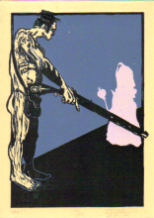Daryl DePry - Henderson, Nevada
Print Title: “Now”
Paper Dimension: 71/4" x 10"
Image Dimension: 6 1/4" x 9"
Block: 7.25"x 10" 1/4 inch Poplar plank
Ink: Daniel Smith
Paper: BFK Rives
Edition: 35
Comments: I used too much Setswell which meddled with the inks viscosity and details filled in. Flats had to be reprinted. Registration though was always on!

Mellissa Read-Devine - Sydney, Australia
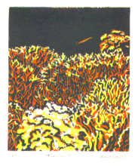Print Title: “Fire Coral”
Paper Dimension: chuban
Image Dimension: 16 x 13 cm
Block: Linoleum
Ink: Oil Based
Paper: Somerset
Edition: 50

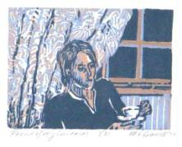Mary Grassell - Hurricane, West Virginia
Title: "Proud of my curtains"

Paper Dimension: 10" x 7.5"
Image Dimension: 6.5" x 4.5"
Block: Wood – Poplar
Ink: Daniel Smith Relief Inks
Paper: Hosho Edition: 31 Comments: The print is being printed by hand in a reduction print method
of three colors. The print is part of a nostalgic series about the pride and care my mother took of her lace curtains when I was growing up, and how much a background to my childhood these lace curtains were.

Karma Grotelueschen - Mineral Point, Wisconsin
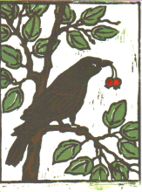Print Title: “Crow Bearing”
Paper Dimension: 7.5 x 10 inches
Image Dimension: 7.5 x 10 inches
Block: Basswood
Ink: Speedball Block Printing Ink,
Acrylic Artist Ink to hand color crabapples
Paper: Rives Heavyweight Cream
Edition: 34
Comments: Crows are ever present yet never as familiar as the songbirds we know and love, and so they intrigued me. Yet, when I read about them,
I was dismayed to hear they had some "bad" habits, such as a very male-dominated society! Is this crow bearing gifts or stealing things away?

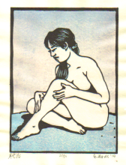
George Jarvis - Akita, Japan
Print Title: “Gekkouyoku” (moon bathing)
Paper Dimension: 19 x 25.5 cm
Image Dimension: 15 x 20 cm
Block: Matsumura shina plywood
Ink: pigment dispersions and Goyo soya black
Paper: Echizen torinoko
Edition: 36
Comments: Gekkouyoku means "moonbathing" in the sense of sunbathing. First attempt at a reduction print. Printed via baren.

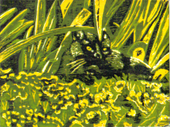Mary Kuster - Lexington, Kentucky
Print Title: “Afternoon Nap”
Paper Dimension: 7.5 X 10 inches
Image Dimension: 7.5 X 10 inches
Block:
Ink:
Paper:
Edition: 45
Comments: Full bleed, 4 color

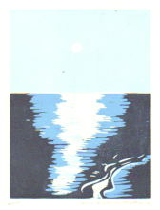
Amanda Gordon Miller - Baltimore, Maryland
Print Title:
Paper Dimension: 7.5 x 10 inches
Image Dimension: 6 x 8 inches
Block: Shina
Ink: Akua Kolor and Akua Intaglio
Paper: Canson
Edition: 33
Comments: This image is based on a photo I took of Lake Michigan when I was a kid. For each color, I used a base of Akua Intaglio and added small amounts of Akua Kolor to get the color I wanted. I chose a simple composition and monochromatic color scheme to minimize the possibility of error in this "suicide print." I really enjoyed this process and look forward to doing more reduction prints.

